Hat Creek Radio Observatory

Paid Time observations

01.03.2021 Version:1.0

## Overview

The Hat Creek Radio Observatory is a multi-disciplinary facility which is operated by the SETI Institute. The observatory houses a number of instruments and research projects. The main instrument on site is the 42-element Allen Telescope Array.

## HCRO use

Use of the Hat Creek Radio Observatory is available on a competitive basis, equal to all research and educational institutions. Observing time of the ATA is granted based on evaluation of proposals. Guest instruments and equipment need to comply with the observatory’s EMI restrictions.

## Services

HCRO offers the following services to research and educational institutions:

* Radio astronomy observing time
  + Using the ATA
* Satellite observing time
  + Using the ATA’s general DSP backend
  + Using the ATA’s USRP backend
* Hosting guest instruments on site
  + Complete systems
  + Antennas
  + Guest receivers on ATA dish
  + DSP testing using IF or RF signals from the ATA

## comercial rate fee

|  |  |
| --- | --- |
| **Activity / Equipment** | **Hourly Rate** |
| **ATA Single Antenna** | $ |
| **ATA (21 antennas)** | $ |
| **Transmitting from HCRO** | $ |
|  | $ |

## Location

|  |  |
| --- | --- |
| **Name** | Hat Creek Radio Observatory |
| **Address** | 42231 Bidwell RD, Hat Creek, CA 96040 |
| **Altitude** | 1008 m |
| **Latitude** | 40° 49' 03" N |
| **Longitude** | 121° 28' 24" W |

## Antennas

|  |  |
| --- | --- |
| **Architecture** | 42 dishes – 6.1 m offset Gregorian |
| **Array maximum baseline** | 300 m |
| **Elevation range** | 16 to 87 deg |
| **Max elevation speed** | 1 deg/sec |
| **Azimuth range** | -90 to 450 deg |
| **Max azimuth speed** | 3 deg/sec |
| **Operating frequency** | 1 – 11.2 GHz |
| **Feed design** | Log-periodic |
| **Polarization** | Dual linear |
| **Feed operating temperature** | 80 Kelvin |
| **System temperature ()** | 45 Kelvin @ 2 GHz; 60 Kelvin @ 8 GHz |
| **HPBW** | 3.5° @ 1 GHz; 0.58° @ 6 GHz; 20.9′ @ 10 GHz; |

## Time standard

|  |  |
| --- | --- |
| **Time sync** | GPS (Meridian II) |
| **Station clock** | Ultra-Stable OCXO |
| **Available reference signals** | 10MHz; 1PPS |
| **Local NTP server** | ntp.hcro.org |

## Radio Frequency (RF)

|  |  |
| --- | --- |
| **Cryogenic low noise amplifier** | LNF-ABLNC1_15A; 35dB gain; 1 – 15 GHz |
| **Post amplifier module (PAM)** | 60dB gain; 0 - 63 dB variable attenuator; 0.5 dB step |
| **PAM 1 dB gain compression** | +8 dBm |
| **Analog fiberoptic link converter** | Photonic Systems; PSI 1601 |
| **Fiber link noise figure** | ≤ 45 dB |
| **Fiberoptic 1 dB gain compression** | +11 dBm |
| **Fiberoptic connectors** | FC/APC |
| **Optical wavelength** | 1550 nm |

## intermediate FREQUENCY (IF)

|  |  |
| --- | --- |
| **Number of independent IF bands** | 4 |
| **IF bandwidth** | 700 MHz |
| **Number of tunable LO** | 4 |
| **Number of fixed LO** | 1 |
| **Frequency range of tunable LO** | 16 – 26.7 GHz |
| **Frequency of fixed LO** | 16.012 GHz |
| **AAF center frequency** | 512 MHz |
| **IF output power range** | -10 dBm to -30 dBm |
| **IF output connector** | SMA |

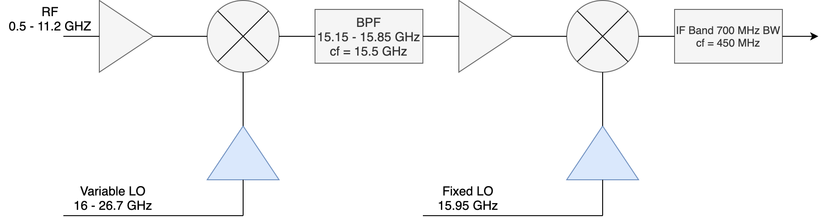

## Control interface

|  |  |
| --- | --- |
| **Telescope control software** | Python 3.5 based library; ATATools.ata_control |
| **GitHub location** | <https://github.com/SETIatHCRO/ATA-Utils> |
| **Software version** | 1.0.3 |
| **Requirements** | 'ephem'; 'astropy'; 'numpy'; 'tftpy'; 'pyuvdata' |

## Network

|  |  |
| --- | --- |
| **Internet connection** | 1 Gbps full duplex |
| **Site access** | VPN; SSH |
| **Available public IPs** | 128 |
| **VPN address** | https://vpn.hcro.seti.org |

